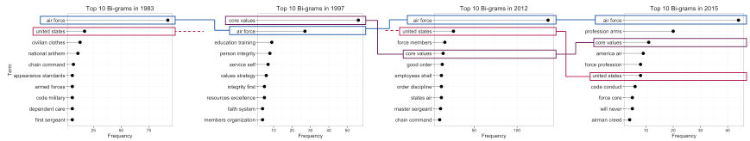

**P1**

Interesting discontinuities worthy of note follow. Consistent with ancillary information [10] for the 2015 version of the text, the term “profession [of] arms” became a frequent bi-gram. Furthermore, certain bi-grams in the 1983 and 2012 versions (i.e. “chain [of] command”, “appearance standards”, “order discipline”, “employees shall) appear to emphasize an instructive or directive tone. Whereas the 1997 and 2015 texts appear to emphasize a more patriotic or virtuous tones (i.e. “personal integrity”, “integrity first”, “profession [of] arms”, “airman creed”). This suggests that oscillation in content and tone may accompany the oscillating descriptive characteristics of the little blue book texts.

**Conclusion**

Making sense of texts can be challenging. While essential, capturing what something *means* is elusive. Textual analysis helps delimit texts, and through the process provides ancillary insights to inform understanding. The early results of our analysis begin to provide analytically-based insights to answer the question of how the little blue book text has changed. Combined, the oscillating content length, changed emphasis in terms, and evolving semantic orientation suggest inconsistencies in the document over time. Although AF leaders may desire these changes in emphasis, it is important to understand that they are counter-productive to establishing a mass belief system and future consistency should be emphasized.

Although preliminary, this analysis illustrates how textual analysis can aid decision-makers in both assessing and developing textual documents. As we continue to unpack texts [21] in the security environment, advancements need to be made to establish a sophisticated text analysis process.

In a national security environment, establishing clarity of intent is required to effectively execute the mission. Whether the emphasis is on core beliefs or war-time proganda, it is unclear when reading or writing a text without analysis is ever adequate. Consequently, expansion of text as something to not only compose and consume but also something to quantitatively analyze is particularly relevant to IE.